Use-Case Realization Report (Analysis)
Set-Up Panels

Issue 3.0
Revision History
Date | Issue | Description | Author
18 July 2000 | 1.0 | First Issue | Howard Russon
2 August 2001 | 2.0 | Revised for MTech Unit 3 in 2001 | Howard Russon
21 July 2004 | 3.0 | Revised for MTech Unit 3 in 2004 | Howard Russon

Table of Contents
1. Brief Description 4
2. Flow of Events 4
2.1 Standard Flow 4
2.1.1 Maintenanace Panel 4
2.1.2 Customer Panel 4
2.1.3 Machinery Simulator Panel 5
2.2 Exceptions 5
3. Interaction Diagrams 6
3.1 Collaboration Diagram: Maintenance Panel 6
3.2 Collaboration Diagram: Customer Panel 7
3.3 Collaboration Diagram: Machinery Simulator Panel 7
4. Participating Objects 8
5. Class Diagrams 9
5.1 Class Diagram: Set-Up Panels 9
6. Derived Requirements 9

Use-Case Realization Report
Set-Up Panels

Brief Description
This use case enables the Controller to use the Simulation Control Panel to display the three main user interface panels of the vending machine simulation: the Customer Panel, the Maintenance Panel and the Machinery Simulator Panel.

Flow of Events
The standard flow of events for this use case and any exceptions are described in the following subsections. The events are described in terms of Actors and Analysis Objects.

Standard Flow
The set-up of the Maintenance Panel, Customer Panel, and Machinery Simulator Panel is described below.

Maintenanace Panel
The flow of events is shown in section 3.1 and described as follows:

- The Controller presses the Activate Maintainer Panel Button on the Simulator Control Panel. This action will trigger the SetupMaintainer operation of the Simulation Controller. The SetupMaintainer operation will deactivate the Activate Maintainer Panel Button (by using its Deactivate operation).
- The SetupMaintainer operation will then instruct the Maintenance Panel to display all its constituent objects and activate/deactivate them. The Maintenance Panel will use operation Display to accomplish this. The constituent objects are: Password Box, Coin Display, Drink Display, Total Cash Display, Exit Button, Price Display, Transfer Cash Button, Cash Collection Tray Display, PasswordValidDisplay, PasswordInvalidDisplay and Total Cash Button.
- The Maintenance Panel will then be instructed to deactivate all its displayed objects except for the Password Box object by using its operation Deactivate.

Customer Panel
The flow of events is shown in section 3.2 and described as follows:

- The Controller presses the Activate Customer Panel Button in the Simulator Control Panel when the Customer Panel is to be displayed. This action triggers the SetupCustomer operation in the Simulation Controller. The SetupCustomer operation will deactivate the Activate Customer Panel Button (by using its operation Deactivate.
- The SetupCustomer operation will instruct the Customer Panel to display all its constituent objects. The Customer Panel will use operation Display to accomplish this. The constituent objects are: Drink Selection Box, Coin Input Box, Can Collection Box, Refund/Change Tray Display, Total Money Inserted Display, Invalid Coin Display, and No Change Available Display. All objects are deactivated.
- The Simulation Controller will then use operation UpdateDrinkSelection of the Dispense Controller to update the drink brands being dispensed and their prices on the Drink Selection Box. For each Drinks Brand, this operation will do the following:
- Use operation GetStock of the Drinks Store to find the current stock level of the brand.
- Use operation GetPrice of the Drinks Store to find the price of the brand.
- Use operation Update of Drink Selection Box to display NO STOCK messages and drink prices on the Drink Selection Box.
- The Simulation Controller will then use operation AllowSelection of the Dispense Controller to activate the Drink Selection Box so that Customer transactions can commence. This is achieved for each brand as follows:
- Operation GetItem of Drinks Store will be used to get a reference to the Drink Store Item that corresponds to the brand.
- Operation GetQuantity of Drink Store Item will be used to determine the current stock level of the brand.
- Operation SetState of the Drink Selection Box will be used to activate or deactivate the buttons according to the stock level.
- The Simulation Controller will then instruct the Change Giver to activate the NO CHANGE AVAILABLE display, if necessary. For this, it uses operation DisplayChangeStatus of the Change Giver . To achieve this, operation GetChangeStatus of Cash Store will be used to determine the change status and then display accordingly. The No Change Available Display will use operation DisplayNoChange to accomplish this.

Machinery Simulator Panel
The flow of events is shown in section 3.3 and described as follows:

- The Controller presses the Activate Machinery Simulator Button on the Simulator Control Panel when the Machinery Simulator Panel needs to be displayed. This action will trigger SetupSimulator operation of the Simulation Controller.
- First, the SetupSimulator operation will deactivate the Activate Machinery Simulator Button.
- Next, the Machinery Simulator Panel will be instructed to display itself and its constituent objects by using operation Display. The constituent objects are: Door Status Display, Cash Store Display and Drinks Store Display.
- The Store Controller will then be instructed to display the current drink stock values on Drinks Store Display by using operation DisplayDrinkStock. The Store Controller will achieved this for each brand as follows:
- Operation GetStock of Drinks Store will be used to determine the new stock level of the dispensed brand.
- Operation Update of the Drinks Store Display will be used to display the new value.
- The Store Controller will then be instructed to display the coin denomination quantity levels on the Cash Store Display by using operation DisplayCoinQuantity. The Store Controller will achieve this for each denomination as follows:
- Use operation GetQuantity of Cash Store to determine the total number of Coins of the denomination held.
- Use operation Update of Cash Store Display to display the value.
- The Store Controller will then determine the appropriate initial value for the Door Status Display using operation GetState of Door. This status will be displayed by using operation Update of the Door Status Display.
- Finally, if the Door is open (unlocked) then the Store Controller will be instructed to activate the Machinery Simulator Panel to accepted user input by using operation ActivateDisplay of Store Controller. This in turn uses operation ActivateDisplay of Machinery Simulator Panel which calls the Activate operation of each of its sub-objects.

Exceptions
The following exceptions have been identified:
- Panel Already Active. If a panel is already active then the respective Activate button will be deactivated. Hence the request to activate the panel will be ignored.
- Fault Identified. If the Simulator Control Panel has received a message saying that a physical fault (in the vending machine) has been discovered, then theActivate Customer Panel Button will be deactivated. Hence requests to activate the Customer Panel will be ignored.
- Maintainer has Logged-In. If the Maintainer has logged-in to the Maintenance Panel then the Activate Customer Panel Button will be deactivated. Hence the Controller will not be permitted to activate the Customer Panel.
- Simulator Has Not Been Started. If the simulator has not been started by pressing the Begin Simulation Button then all the Activate buttons will be deactivated. Hence requests to activate any of the panels will be ignored.

Interaction Diagrams

Collaboration Diagram: Maintenance Panel
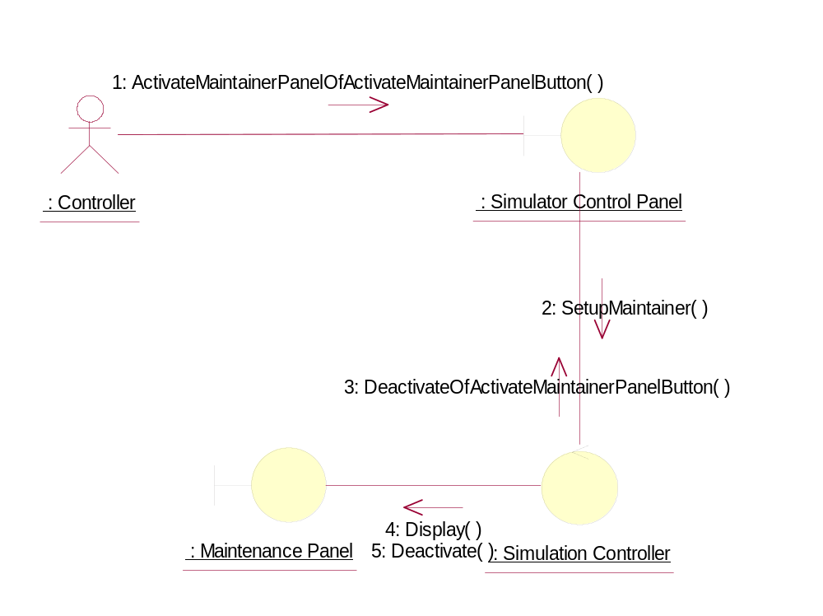

Collaboration Diagram: Customer Panel
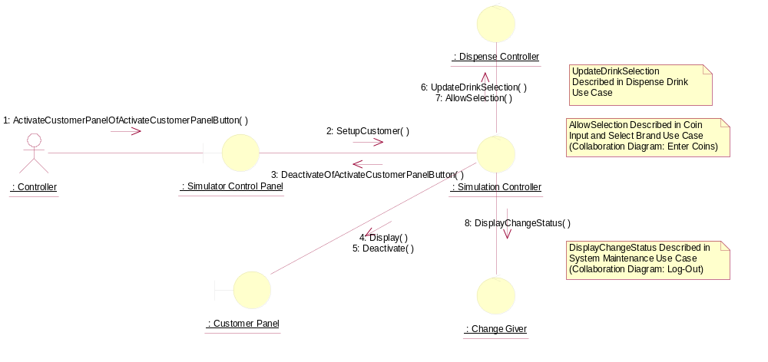

Collaboration Diagram: Machinery Simulator Panel
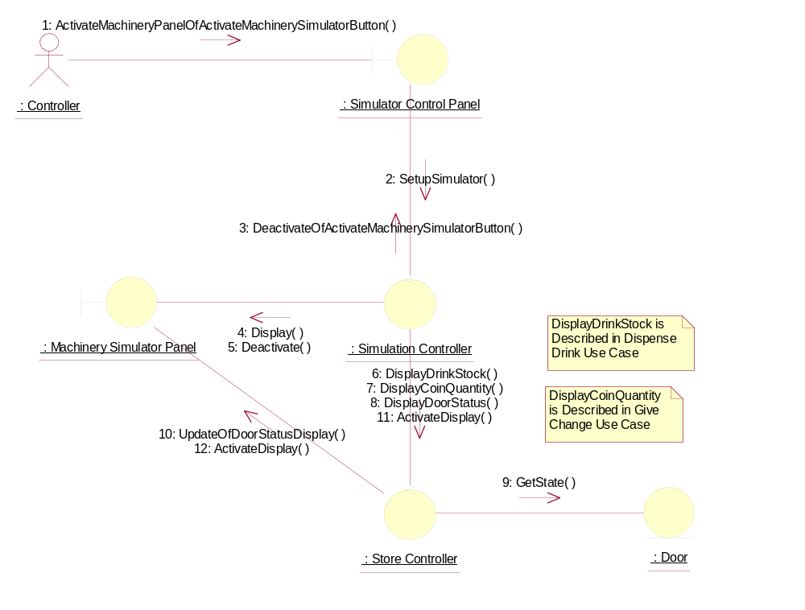

Participating Objects
: Change Giver
This control object manages the giving of change to the Customer.
: Controller
This actor represents the controller of the VMCS simulation. Hence it is only present in the simulated system (ie: this project) and would not be an actor of the target implementation. In particular, it performs several of the physical activities (ie: those that can not be provided by software) that are undertaken by the Maintainer in the target implementation, which include maintaining drink stocks and cash stocks inside the vending machine.
: Customer Panel
This panel simulates the vending machine's customer interface panel. It will enable the user (the Customer) to:
1 insert coins;
2 select brands;
3 terminate transaction.
It will also provide the following display functions:
1 display total money inserted;
2 indicate coin not valid;
3 indicate no change available;
4 display the value of the change to be collected;
5 display an icon representing the dispensed drink.
: Dispense Controller
This control object is for handling the dispense drink use case.
: Door
This object represents the door of the vending machine. It is opened so that the machine can be restocked with cans and cash.
: Machinery Simulator Panel
This panel simulates the physical actions of the maintainer. It enables the user to:
1 display and enter new values for the number of cans of each Drinks Brand held by the Drinks Store;
2 display and enter new values for the number of Coins of each denomination held by the Cash Store;
3 display whether the vending machine Door is unlocked, and enable it to be locked.
: Maintenance Panel
This panel simulates the vending machines maintainer control panel. It will enable the user (the Maintainer) to:
1 log-on using a password;
2 display number of Coins of each denomination in the Cash Store;
3 display total value of cash in the system;
4 display number cans of each Drinks Brand held in the Drinks Store;
5 change the price of any Drinks Brand;
6 collect all cash held in system;
7 formally exit from the panel.
: Simulation Controller
This control object is used to set up the 3 panels (Customer Panel, Maintenance Panel and the Machinery Simulator Panel) of the vending machine.
: Simulator Control Panel
This panel is displayed when the system is started up. It enables the user (the Controller) to :
1 start (switch on);
2 stop (switch off);
3 activate the customer panel;
4 activiate the maintenance panel;
5 activate the machinery simulator panel.
: Store Controller
This object controls the Change State use case. It mangages changes in Cash Store attributes and the Drinks Store attributes. It also handles the door status. It is also used by the Dispense Drink use case to update the Drinks Store attributes.

Class Diagrams

Class Diagram: Set-Up Panels
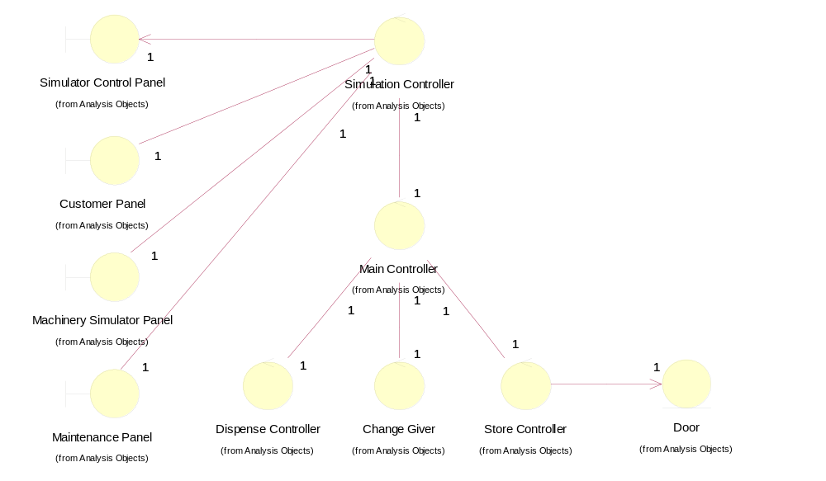

Derived Requirements
The Maintenance Panel, Customer Panel, and Machinery Simulator Panel should have the format specified in figures 3, 4 and 5 respectively of "User Requirements Specification for Vending Machine Control System (VMCS) Computer Simulation", reference ISS/VMCS/TR.1/1.

